Meta-analysis to Assess the Impact of Centre’s Heart Transplant Status and Volume on in-hospital Outcomes Following Extracorporeal Membrane Oxygenation for Refractory Post-cardiotomy Cardiogenic Shock

- Impact of Transplant Status and Volume on ECMO results -

SUPPLEMENTARY APPENDIX
Legend to Appendix Figures.

Appendix Figure 1. Publication bias analysis
Appendix Figure 2. Analysis of brain death following ECMO institution in HTx/VAD vs non-HTx/VAD centres. Squares represent point estimates of single studies; horizontal lines are respective 95% confidence intervals. Diamonds are indicative of subtotal and total pooled estimate. HTx, heart transplantation; VAD, ventricle assist device; CIs, confidence intervals.
Appendix Figure 3. Meta-regression analysis of number of ECMOs per year on logit brain death event rate. Abbreviations as in Appendix Figure 2.
Appendix Figure 4. Meta-regression analysis of number of ECMOs per year on logit reoperations for bleeding event rate. Abbreviations as in Appendix Figure 2.
Appendix Figure 5. Meta-regression analysis of number of ECMOs per year on logit sepsis event rate. Abbreviations as in Appendix Figure 2.
Appendix Figure 6. Meta-regression analysis of number of ECMOs per year on logit acute kidney injury event rate. Abbreviations as in Appendix Figure 2.
Appendix Figure 7. Subgroup analysis to assess impact of centre volume on survival: arbitrary thresholds. Abbreviations as in Appendix Figure 2.
Appendix Figure 8. Subgroup analysis to assess impact of centre volume on survival: thresholds divided by mean and median number of ECMOs per year and divided in tertiles and quartiles. Abbreviations as in Appendix Figure 2.

Appendix Figure 1.

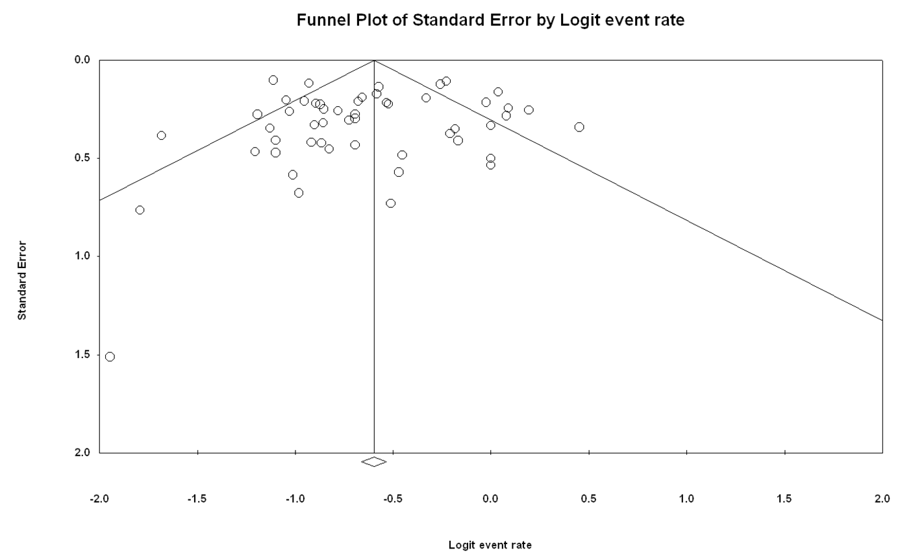

Appendix Figure 2
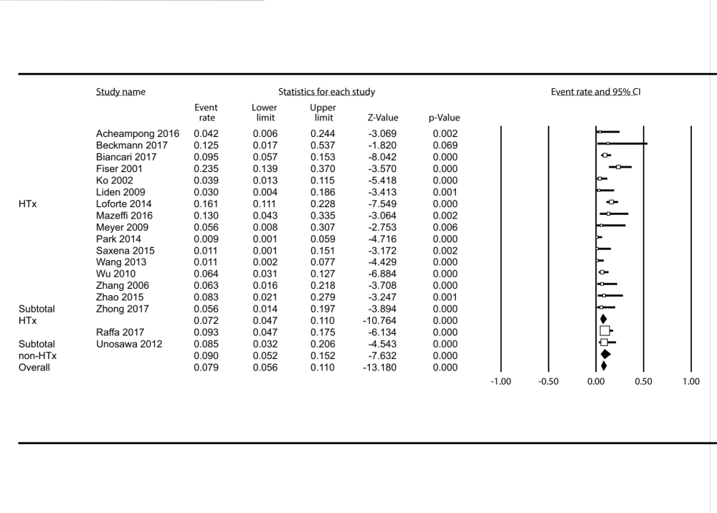

Appendix Figure 3.
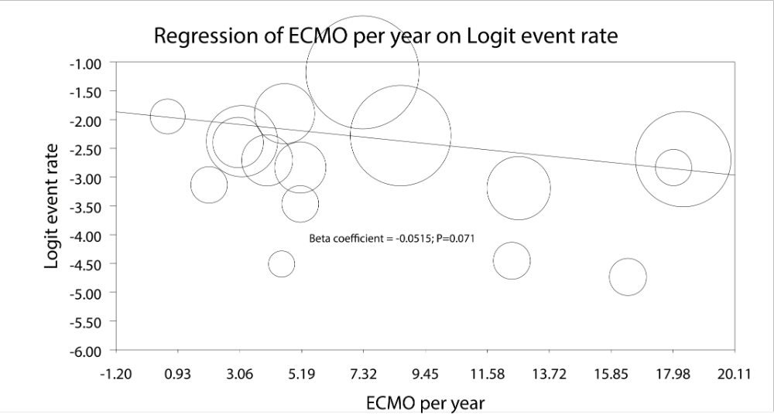

Appendix Figure 4.

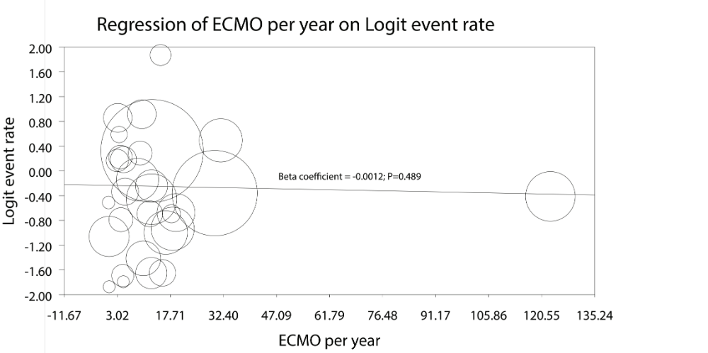
Appendix Figure 5.

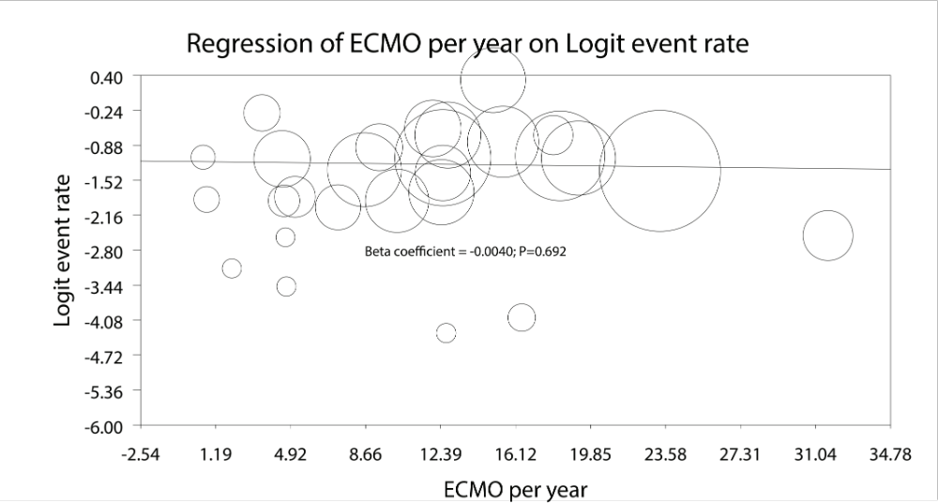

Appendix Figure 6.
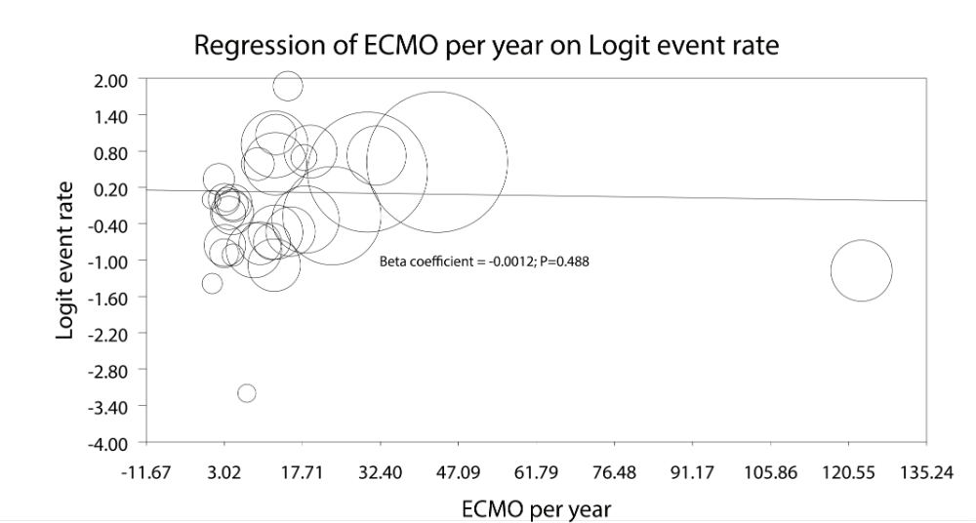

Appendix Figure 7.

Appendix Figure 8.

Appendix Table 1. PRISMA checklist
Section/topic | # | Checklist item | Reported on page #
TITLE
Title | 1 | Identify the report as a systematic review, meta-analysis, or both. | 1
ABSTRACT
Structured summary | 2 | Provide a structured summary including, as applicable: background; objectives; data sources; study eligibility criteria, participants, and interventions; study appraisal and synthesis methods; results; limitations; conclusions and implications of key findings; systematic review registration number. | 4-5
INTRODUCTION
Rationale | 3 | Describe the rationale for the review in the context of what is already known. | 6-7
Objectives | 4 | Provide an explicit statement of questions being addressed with reference to participants, interventions, comparisons, outcomes, and study design (PICOS). | 7
METHODS
Protocol and registration | 5 | Indicate if a review protocol exists, if and where it can be accessed (e.g., Web address), and, if available, provide registration information including registration number. | NA
Eligibility criteria | 6 | Specify study characteristics (e.g., PICOS, length of follow-up) and report characteristics (e.g., years considered, language, publication status) used as criteria for eligibility, giving rationale. | 7-8
Information sources | 7 | Describe all information sources (e.g., databases with dates of coverage, contact with study authors to identify additional studies) in the search and date last searched. | 7
Search | 8 | Present full electronic search strategy for at least one database, including any limits used, such that it could be repeated. | NA
Study selection | 9 | State the process for selecting studies (i.e., screening, eligibility, included in systematic review, and, if applicable, included in the meta-analysis). | 8-9
Data collection process | 10 | Describe method of data extraction from reports (e.g., piloted forms, independently, in duplicate) and any processes for obtaining and confirming data from investigators. | 8
Data items | 11 | List and define all variables for which data were sought (e.g., PICOS, funding sources) and any assumptions and simplifications made. | 9
Risk of bias in individual studies | 12 | Describe methods used for assessing risk of bias of individual studies (including specification of whether this was done at the study or outcome level), and how this information is to be used in any data synthesis. | 8-9
Summary measures | 13 | State the principal summary measures (e.g., risk ratio, difference in means). | 9-10
Synthesis of results | 14 | Describe the methods of handling data and combining results of studies, if done, including measures of consistency (e.g., I²) for each meta-analysis. | 9-10

Page 1 of 2
Section/topic | # | Checklist item | Reported on page #
Risk of bias across studies | 15 | Specify any assessment of risk of bias that may affect the cumulative evidence (e.g., publication bias, selective reporting within studies). | 11
Additional analyses | 16 | Describe methods of additional analyses (e.g., sensitivity or subgroup analyses, meta-regression), if done, indicating which were pre-specified. | 10
RESULTS
Study selection | 17 | Give numbers of studies screened, assessed for eligibility, and included in the review, with reasons for exclusions at each stage, ideally with a flow diagram. | Fig 1
Study characteristics | 18 | For each study, present characteristics for which data were extracted (e.g., study size, PICOS, follow-up period) and provide the citations. | Table 1, p.11-12
Risk of bias within studies | 19 | Present data on risk of bias of each study and, if available, any outcome level assessment (see item 12). | App. Fig 1. P 11
Results of individual studies | 20 | For all outcomes considered (benefits or harms), present, for each study: (a) simple summary data for each intervention group (b) effect estimates and confidence intervals, ideally with a forest plot. | P. 12-14, Figures
Synthesis of results | 21 | Present results of each meta-analysis done, including confidence intervals and measures of consistency. | 12-14
Risk of bias across studies | 22 | Present results of any assessment of risk of bias across studies (see Item 15). | App. Fig. 1
Additional analysis | 23 | Give results of additional analyses, if done (e.g., sensitivity or subgroup analyses, meta-regression [see Item 16]). | App Figures
DISCUSSION
Summary of evidence | 24 | Summarize the main findings including the strength of evidence for each main outcome; consider their relevance to key groups (e.g., healthcare providers, users, and policy makers). | 15-18
Limitations | 25 | Discuss limitations at study and outcome level (e.g., risk of bias), and at review-level (e.g., incomplete retrieval of identified research, reporting bias). | 18
Conclusions | 26 | Provide a general interpretation of the results in the context of other evidence, and implications for future research. | 18-19
FUNDING
Funding | 27 | Describe sources of funding for the systematic review and other support (e.g., supply of data); role of funders for the systematic review. | 19

From: Moher D, Liberati A, Tetzlaff J, Altman DG, The PRISMA Group (2009). Preferred Reporting Items for Systematic Reviews and Meta-Analyses: The PRISMA Statement. PLoS Med 6(7): e1000097. doi:10.1371/journal.pmed1000097
For more information, visit: www.prisma-statement.org.
Page 2 of 2

Appendix Table 2. ROBINS-I tool bias assessment.
Study | Bias due to confounding | Bias in selection of participants into the study | Bias in measurement of interventions | Bias due to departures from intended interventions | Bias due to missing data* | Bias in measurement of outcomes* | Bias in selection of reported result* | Overall bias | Cohen’s Kappa
Acheampong  2016 [19] | Critical | Critical | Serious | NA | Moderate | Moderate | Moderate | Moderate | 0.57
Bakhtiary  2008 [20] | Critical | Low | Serious | NA | Moderate | Low | Low | Low | 0.71
Beckmann  2017 [21] | Critical | Critical | Serious | NA | Low | Moderate | Moderate | Critical | 0.71
Beiras-Fernandez  2011 [22] | Critical | Low | Low | NA | Low | Critical | Critical | Critical | 0.71
Biancari  2017 [23] | Critical | Low | Serious | NA | Low | Low | Low | Low | 0.86
Burrell  2015 [24] | Critical | Critical | Low | NA | Moderate | Moderate | Moderate | Moderate | 0.86
Carroll  2015 [25] | Critical | Low | Moderate | NA | Serious | Critical | Serious | Critical | 0.57
Chen  2011 [26] | Critical | Critical | Critical | NA | Serious | Critical | Critical | Critical | 0.86
Combes  2008 [27] | Critical | Low | Low | NA | Serious | Critical | Critical | Critical | 0.86
Distelmeier  2016 [28,29] | Critical | Low | Low | NA | Moderate | Critical | Serious | Critical | 0.86
Doll  2003 [30] | Critical | Low | Low | NA | Moderate | Low | Low | Low | 0.71
Elsharkawy  2010 [31] | Critical | Low | Low | NA | Low | Moderate | Moderate | Low | 0.71
Fiser  2001 [32] | Critical | Low | Critical | NA | Moderate | Moderate | Moderate | Moderate | 0.86
Guihaire  2017 [33] | Critical | Serious | Low | NA | Low | Moderate | Moderate | Moderate | 0.86
Hsu  2009 [34] | Critical | Low | Low | NA | Moderate | Moderate | Moderate | Moderate | 0.86
Kanji  2010 [35] | Critical | Low | Serious | NA | Serious | Moderate | Moderate | Serious | 1
Ko  2002 [36] | Critical | Low | Critical | NA | Low | Moderate | Moderate | Critical | 0.86
Lamarche  2010 [37] | Critical | Low | Moderate | NA | Moderate | Moderate | Moderate | Moderate | 0.57
Li  2015 [38] | Critical | Low | Low | NA | Low | Moderate | Moderate | Low | 0.86
Liden  2009 [39] | Critical | Moderate | Critical | NA | Moderate | Moderate | Moderate | Moderate | 0.57
Liu  2009 [40] | Critical | Critical | Moderate | NA | Low | Moderate | Moderate | Moderate | 0.71
Loforte  2014 [41] | Critical | Low | Critical | NA | Moderate | Moderate | Low | Critical | 0.71
Luo  2009 [42] | Critical | Low | Low | NA | Moderate | Moderate | Low | Low | 1
Mazeffi  2016 [43] | Critical | Low | Moderate | NA | Low | Moderate | Moderate | Moderate | 1
Meyer  2009 [44] | Critical | Low | Low | NA | Moderate | Moderate | Moderate | Moderate | 0.86
Musial  2017 [45] | Critical | Low | Critical | NA | Low | Serious | Moderate | Critical | 0.71
Papadopoulos  2015 [46] | Critical | Low | Low | NA | Low | Moderate | Moderate | Low | 0.86
Park  2014 [47] | Critical | Moderate | Low | NA | Low | Moderate | Moderate | Moderate | 0.86
Peigh  2015 [48] | Critical | Low | Critical | NA | Serious | Critical | Critical | Critical | 0.57
Pokersnik  2012 [49] | Critical | Serious | Critical | NA | Low | Moderate | Moderate | Critical | 0.71
Pontailler  2017 [50] | Critical | Low | Serious | NA | Serious | Critical | Critical | Critical | 0.86
Ranucci  2011 [51] | Critical | Critical | Critical | NA | Critical | Critical | Critical | Critical | 0.86
Rastan  2010 [52] | Critical | Low | Low | NA | Low | Moderate | Moderate | Low | 0.71
Rousse  2015 [53] | Critical | Low | Serious | NA | Moderate | Critical | Serious | Critical | 0.71
Rubino  2017 [54] | Critical | Low | Critical | NA | Low | Moderate | Moderate | Critical | 0.71
Russo  2010 [55] | Critical | Low | Low | NA | Low | Critical | Serious | Low | 0.71
Saxena  2015 [9] | Critical | Low | Low | NA | Low | Moderate | Moderate | Low | 0.86
Slottosch  2012 [56] | Critical | Low | Low | NA | Low | Low | Moderate | Low | 0.86
Slottosch  2017 [57] | Critical | Low | Low | NA | Moderate | Moderate | Moderate | Moderate | 0.86
Truby  2015 [58] | Critical | Low | Serious | NA | Moderate | Critical | Serious | Critical | 0.86
Tsai  2016 [59] | Critical | Critical | Critical | NA | Serious | Critical | Critical | Critical | 0.57
Wang  2009 [60] | Critical | Low | Low | NA | Moderate | Low | Moderate | Low | 0.71
Wang  2013 [61] | Critical | Critical | Low | NA | Low | Low | Moderate | Low | 0.86
Wu  2010 [62] | Critical | Low | Critical | NA | Low | Low | Low | Low | 1
Xie  2017 [63] | Critical | Low | Critical | NA | Critical | Critical | Critical | Critical | 0.86
Zhang  2006 [64] | Critical | Low | Critical | NA | Low | Serious | Moderate | Critical | 0.86
Zhao  2015 [65] | Critical | Critical | Critical | NA | Low | Moderate | Moderate |  | 0.71
Zhong  2017 [66] | Critical | Critical | Low | NA | Low | Serious | Moderate | Critical | 0.57
Ariyaratnam  2014 [67] | Critical | Low | Critical | NA | Low | Critical | Serious | Critical | 1
Deschka  2013 [68] | Critical | Low | Serious | NA | Moderate | Low | Low | Low | 0.86
Khorsandi  2016 [69] | Critical | Low | Serious | NA | Low | Low | Low | Low | 0.86
Mikus  2013 [70] | Critical | Low | Low | NA | Low | Moderate | Moderate | Low | 0.71
Raffa  2017 [71] | Critical | Low | Serious | NA | Low | Moderate | Low | Low | 0.71
Unosawa  2012 [72] | Critical | Low | Low | NA | Low | Moderate | Moderate | Low | 0.86
*When multiple outcomes were reported for a study, the highest level of bias at the outcome level is reported in the table.

Appendix Table 2. Procedural characteristics
Study |  | Post-op IABP (n) | Peripheral cannulation (n) |  | ECMO at index procedure (n) |  | ECMO at OR/ICU |  | Distal perfusion (n) |  | LV venting (n) |  | ECMO
 |  |  |  |  |  |  |  |  |  |  |  |  | Duration |  | weaning (%) |  | Bridge to VAD (n) |  | Bridge to HTx (n)
HTx/VAD centres
 | Acheampong 2016 | 14 |  | NR |  | NR |  | 20/4 |  | NR |  | NR |  | 8.4 (0.8–35.4) days |  | 75.0 |  | 1 |  | 0
 | Bakhtiary 2008 | 30 |  | 37 |  | NR |  | 30/15 |  | NR |  | NR |  | 6.4 ± 4.5 days |  | 55.6 |  | 5 |  | 2
 | Beckmann 2017 | NR |  | 8 |  | NR |  | NR |  | 8 |  | NR |  | 12.0 ± 5.9 days |  | 87.5 |  | 1 |  | 0
 | Beiras-Fernandez 2011 | 36 |  | NR |  | NR |  | NR |  | NR |  | NR |  | 4.4 ± 4.0 days |  | NR |  | NR |  | NR
 | Biancari 2017 | 47 |  | 89 |  | 76 |  | NR |  | 66 |  | 5 |  | 6.4 ± 5.6 days |  | 48.6 |  | 6 |  | 0
 | Burrell 2015 | NR |  | NR |  | NR |  | NR |  | NR |  | NR |  | 7 (IQR: 5-8) days |  | 100 |  | NR |  | NR
 | Carroll 2015 | 13 |  | 92 |  | NR |  | 61/31** |  | NR |  | NR |  | 94 (IQR: 43-172) hours |  | 69 |  | 29 |  | 2
 | Chen 2011* | NR |  | NR |  | NR |  | NR |  | NR |  | NR |  | 133 ± 12 hours |  | 54.9 |  | NR |  | NR
 | Combes 2008 | NR |  | NR |  | NR |  | NR |  | NR |  | NR |  | NR |  | NR |  | NR |  | NR
 | Distelmeier 2016/2017 | 44 |  | 347 |  | NR |  | NR |  | NR |  | NR |  | 4 (IQR: 2–7) days |  | NR |  | 4 |  | 3
 | Doll 2003 | 95 |  | 26 |  | NR |  | 70/25 |  | NR |  | NR |  | 2.8 ± 2.1 days |  | 47.4 |  | 8 |  | 3†
 | Elsharkawy 2010 | 22 |  | 77 |  | NR |  | NR |  | NR |  | NR |  | NR |  | NR |  | 28 |  | 25
 | Fiser 2001 | NR |  | NR |  | NR |  | 22/29 |  | NR |  | NR |  | 67.5 hours |  | 31.4 |  | NR |  | NR
 | Guihaire 2017 | 25 |  | 78 |  | 43 |  | 80/12 |  | NR |  | 13 |  | 6 days |  | 48 |  | 2 |  | 2
 | Hsu 2009 | 51 |  | 51 |  | NR |  | NR |  | NR |  | NR |  | 7.5 ± 6.7 days |  | 52.9 |  | 0 |  | 3
 | Kanji 2010 | 36 |  | 22 |  | NR |  | NR |  | NR |  | NR |  | 2.5 (IQR: 1.0-4.8) days |  | NR |  | NR |  | 23
 | Ko 2002 | 54 |  | 61 |  | 39 |  | 23/30 |  | 20 |  | NR |  | NR |  | 60.5 |  | 2 |  | 2
 | Lamarche 2010 | NR |  | 8 |  | NR |  | 16/8 |  | NR |  | NR |  | 48 ± 65.5 hours |  | 58.3 |  | 3 |  | 3
 | Li 2015 | 73 |  | 123 |  | 61 |  | NR |  | 123 |  | NR |  | 4.3 days |  | 56.1 |  | NR |  | NR
 | Liden 2009 | 14 |  | NR |  | NR |  | NR |  | NR |  | NR |  | 5.5 ± 4.9 days |  | NR |  | 2 |  | 2
 | Liu 2009 | 10 |  | 14 |  | 9 |  | NR |  | NR |  | NR |  | 71 ± 52 hours |  | 64.3 |  | NR |  | NR
 | Loforte 2014 | 155 |  | 79 |  | NR |  | NR |  | NR |  | NR |  | 9.56 (2–43) days |  | 56.8 |  | 1 |  | 4
 | Luo 2009 | 11 |  | NR |  | NR |  | 15/30 |  | NR |  | 0 |  | 131.6 hours |  | 66.7 |  | NR |  | 2
 | Mazeffi 2016 | 3 |  | 9 |  | 3 |  | NR |  | NR |  | 0 |  | 3 (IQR: 1-8) days |  | 100 |  | 2 |  | NR
 | Meyer 2009 | NR |  | 18 |  | NR |  | NR |  | 18 |  | NR |  | 4 ± 4 days |  | 66.7 |  | NR |  | NR
 | Musial 2017 | NR |  | 27 |  | 27 |  | NR |  | NR |  | NR |  | 8.89 days |  | NR |  | NR |  | NR
 | Papadopoulos 2015 | NR |  | 324 |  | NR |  | NR |  | NR |  | NR |  | 7 ± 1 days |  | 58.1 |  | 6 |  | 2
 | Park 2014 | NR |  | 115 |  | 41 |  | NR |  | 115 |  | NR |  | 71.3 (0.5-713) hours |  | 40.8 |  | NR |  | 2
 | Peigh 2015 | NR |  | NR |  | NR |  | NR |  | NR |  | NR |  | 9.2 ± 6.1 days |  | NR |  | NR |  | NR
 | Pokersnik 2012 | 29 |  | 32 |  | NR |  | NR |  | 32 |  | NR |  | 3.8 ± 3.4 days |  | 55.1 |  | 2 |  | 0
 | Pontailler 2017 | NR |  | NR |  | NR |  | NR |  | NR |  | NR |  | 5.6 ± 4.3 days* |  | 41.1* |  | NR |  | NR
 | Ranucci 2011 | NR |  | 0 |  | 9/2 |  | NR |  | NR |  | NR |  | 122.1 ± 80.5 hours |  | 63.6 |  | NR |  | NR
 | Rastan 2010 | 383 |  | 203 |  | NR |  | NR |  | 121 |  | NR |  | 3.28 ± 2.85 days |  | 63.3 |  | 15 |  | 5
 | Rousse 2015 | 5 |  | 25 |  | NR |  | NR |  | 29 |  | 29 |  | 8 (1-86) days |  | 50.0 |  | 7 |  | 13
 | Rubino 2017 | NR |  | NR |  | 63 |  | NR |  | NR |  | NR |  | 5 (IQR: 3-8) days |  | 57.4 |  | 3 |  | 3
 | Russo 2010 | 3 |  | 1 |  | NR |  | NR |  | NR |  | NR |  | 7.0 ± 5.2 days |  | 66.7 |  | 0 |  | 1
 | Saxena 2015† | NR |  | 15 |  | NR |  | NR |  | NR |  | NR |  | 103.8 ± 74.3 hours |  | 53.3 |  | NR |  | NR
 | Slottosch 2012 | 72 |  | 77 |  | 34 |  | 34/43 |  | 77 |  | NR |  | 79 ± 57 hours |  | 62.3 |  | NR |  | NR
 | Slottosch 2017 | 83 |  | 72 |  | 40 |  | NR |  | NR |  | NR |  | 117 ± 78 hours |  | 43.2* |  | NR |  | NR
 | Truby 2015 | NR |  | 45 |  | NR |  | 71/108 |  | 9 |  | NR |  | 3.58 (IQR: 1.6 –5.9) days |  | NR |  | 52 |  | NR
 | Tsai 2016 | NR |  | NR |  | NR |  | NR |  | NR |  | NR |  | 7 ± 5 days* |  | 70.5* |  | NR |  | NR
 | Wang 2009 | 19 |  | NR |  | NR |  | 36/26 |  | NR |  | 0 |  | 61 ± 37 hours |  | 64.5 |  | NR |  | NR
 | Wang 2013 | 41 |  | NR |  | 37 |  | 37/50 |  | 37 |  | NR |  | 61 ± 37 hours |  | 58.6 |  | NR |  | NR
 | Wu 2010 | NR |  | NR |  | NR |  | 98/12 |  | NR |  | NR |  | 143 ± 112 hours |  | 60.9 |  | 2 |  | 0
 | Xie 2017*** | NR |  | NR |  | NR |  | NR |  | NR |  | NR |  | NR |  | 64.8 |  | NR |  | NR
 | Zhang 2006 | 10 |  | 19 |  | NR |  | NR |  | NR |  | NR |  | 2.7 ± 1.7 days |  | 43.8 |  | NR |  | NR
 | Zhao 2015 | 16 |  | 23 |  | 9 |  | NR |  | NR |  | NR |  | 115.23 ± 70.17 hours |  | 66.7 |  | 1** |  | NR
 | Zhong 2017 | 9 |  | 29 |  | 24 |  | 24/12 |  | NR |  | NR |  | 77.5 ± 34.5 hours |  | 66.7 |  | NR |  | NR
Non-HTx/VAD centres
 | Ariyaratnam 2014 | NR |  | 0 |  | NR |  | NR |  | NR |  | NR |  | 5.6 ± 3.4 days |  | 50.0 |  | NR |  | NR
 | Deschka 2013 | 25 |  | 0*** |  | NR |  | NR |  | NR |  | NR |  | 8.7 ± 3.9 days |  | 42.9 |  | NR |  | NR
 | Khorsandi 2016 | NR |  | 5 |  | NR |  | NR |  | NR |  | NR |  | 5.5 ± 8.9 days |  | NR |  | NR |  | NR
 | Mikus 2013 | 13 |  | 6 |  | 12 |  | NR |  | 14 |  | 14 |  | 5 days |  | 50 |  | 0 |  | 0
 | Raffa 2017 | 23 |  | 30 |  | 48 |  | 48/38 |  | NR |  | NR |  | 5 days |  | 49 |  | NR |  | NR
 | Unosawa 2012 | 39 |  | 32 |  | 33 |  | 33/14 |  | NR |  | NR |  | 63.5 ± 61.5 hours |  | 61.7 |  | 0 |  | 0
* Reported for entire study population including non-PCS patients
** 24 (23%) in the cardiac catheterization laboratory, 16 (16%) at the bedside, and 1 (1%) in the emergency department
*** Central cannulation cohort alone; peripheral venous cannulation in 28 patients
†VAD and subsequent heart transplantation
Values are reported as mean ± SD, unless reported otherwise in the original manuscript. HTx, heart transplantation; VAD, ventricular assist device; IQR, interquartile range; NR, not reported.

Numbers of patients in single studies do not always match the total n. of patients in the original manuscripts since only PCS subgroups were considered.

Appendix Table 3. Reported causes of in-hospital/30-day death
Study |  | On ECMO only | After weaning/in-hospital/30-day death
HTx/VAD centres
 | Acheampong 2016 | NR | 1 sepsis, 1 massive bleeding, 2 pulmonary; remaining: multiorgan failure or cardiac related
 | Bakhtiary 2008 | 18 persistent heart failure | 12 multiorgan failure
 | Beckmann 2017 | 1 sepsis | 1 biventricular failure, 1 low cardiac output, 1 cerebral haemorrhage, 1 multiorgan failure
 | Beiras-Fernandez 2011 | refractory ventricular failure 40.6%, bleeding 23.2%, isolated persistent low cardiac output 21.7%, thromboembolism 8.7%, allograft failure 5.8% | NR
 | Biancari 2017 | NR | NR
 | Burrell 2015 | NR | NR
 | Carroll 2015 | NR | multiorgan failure in 52 patients, neurologic injury in 9 patients, bleeding in 7 patients, hypoxemic respiratory failure in 2 patients, and other etiologies in the remaining 5 patients
 | Chen 2011* | NR | NR
 | Combes 2008 | mainly due to refractory multiorgan failure with 14 within 24 hrs of onset | NR
 | Distelmeier 2016/2017 | NR | NR
 | Doll 2003 | NR | refractory myocardial failure in 71%, multisystem organ failure in 13%, sepsis in 7%, and other causes in 9%
 | Elsharkawy 2010 | NR | NR
 | Fiser 2001 | 27 cardiac failures, 12 strokes, 3 multisystem organ failures, 1 respiratory insufficiency | NR
 | Guihaire 2017 | NR | NR
 | Hsu 2009 | NR | main causes were pulmonary infections
 | Kanji 2010 | NR | NR
 | Ko 2002 | 16 multiple organ failure, 5 uncontrolled bleedings, 3 brain deaths, 2 circulatory shocks, 1 refractory ventricular arrhythmia, 1 myocardial infarction, 1 acute rejection, 1 graft failure | 17 multiple organ failure, 3 persistent heart failure, 1 ventricular fibrillation
 | Lamarche 2010 | NR | NR
 | Li 2015 | NR | NR
 | Liden 2009 | 8 multiorgan failure, 6 poor cardiac function, 1 brain damage, 1 retroperitoneal bleeding, 1 fungal sepsis, 1 vasoplegia, 1 unknown | NR
 | Liu 2009 | NR | 4 haemodynamic unstable, 1 multiorgan failure, 1 sepsis, 1 other
 | Loforte 2014 | mostly associated with sepsis and brain death | NR
 | Luo 2009 | 6 persistent heart failure without improvement, 4 multiorgan failure and others | 5 sepsis and other
 | Mazeffi 2016 | NR | 7 multiple organ failure, 4 brain injury, 3 sepsis, 1 hemorrhage, 1 repeat arrest
 | Meyer 2009 | NR | 5 multiorgan failure, 4 non-recoverable myocardial failure, 3 sepsis, 1 intracerebral bleeding
 | Musial 2017 | NR | NR
 | Papadopoulos 2015 | NR | the main cause of death was sepsis (69%)
 | Park 2014 | NR | 6 multiorgan failure, 3 profound cardiac failure, 2 sepsis, 2 pan-peritonitis, 2 aortic ruptures, 1 intracerebral haemorrhage, 1 gastrointestinal bleeding
 | Peigh 2015 | 8 anoxic brain injuries, 8 strokes, 3 irreversible cardiac dysfunctions, 3 sepsis, 2 irreversible lung diseases, 1 abdominal compartment syndrome with hepatorenal syndrome, 1 failure to control bleeding | 5 sepsis, 4 neurologic injuries, 2 acute myocardial infraction because of stent thrombosis, 1 family’s withdrawal because of failure to thrive, and one case of each of the following: pulseless electric activity after internal defibrillator placement, persistent loss of cardiac activity despite biventricular assist device placement, acute failure of left ventricular assist device placement with persistent low flow and malperfusion, nonresectable cardiac metastasis (adenocarcinoma), and severe coagulopathy and multiple bleeding
 | Pokersnik 2012 | NR | NR
 | Pontailler 2017 | multiorgan failure for all patients | NR
 | Ranucci 2011 | NR | NR
 | Rastan 2010 | NR | the main reason for death was cardiac
 | Rousse 2015 | 21 multiple organ failures, 12 intra-abdominal bleeding, 4 strokes, 3 non-beating hearts, 7 haemorrhage or sepsis, 2 mesenteric ischemias (for entire study population of 124 patients) | NR
 | Rubino 2017 | NR | causes of death were mostly related to cardiac disease
 | Russo 2010 | NR | 6 multiorgan failures, 1 pulmonary artery thrombosis, 1 thoracic bleeding
 | Saxena 2015† | NR | 30 cardiac causes, 13 multiorgan failures, 6 septicemias
 | Slottosch 2012 | NR | cardiac causes (50.9%), sepsis (29.1%), cerebrovascular complications (1.8%), bleeding (10.9%), gastrointestinal complications (7.3%)
 | Slottosch 2017 | NR | 60 cardiac deaths, 22 sepsis, 6 mesenterial ischemias, 5 cerebral deaths, 5 untreatable bleedings and 4 others (for entire cohort of 139 patients)
 | Truby 2015 | NR | NR
 | Tsai 2016 | NR | NR
 | Wang 2009 | 11 persistent heart failures, 7 sepsis with consecutive multiorgan failure, 2 cerebral infarction and bleeding, 2 disseminated intravascular coagulation | main cause was sepsis with consecutive multiorgan failure
 | Wang 2013 | 22 persistent heart failure without any improvement in cardiac function, 10 sepsis, 3 disseminated intravascular coagulation, 1 cerebral infarction and bleeding | sepsis with consecutive multiorgan failure for all weaned
 | Wu 2010 | NR | 8 excessive mediastinal bleeding, 15 profound cardiac failure, 6 severe brain damage, 3 bowel infarction, 2 massive air embolism, 28 sepsis with multiple organ failure
 | Xie 2017*** | NR | NR
 | Zhang 2006 | NR | NR
 | Zhao 2015 | NR | the main cause of mortality was multiple system organ failure (50.0 %)
 | Zhong 2017 | NR | 7 sepsis with subsequent multi-organ failure, 6 persistent heart failures, 3 disseminated intravascular coagulation, 2 cerebral infarction
Non-HTx/VAD centres
 | Ariyaratnam 2014 | NR | NR
 | Deschka 2013 | NR | NR
 | Khorsandi 2016 | NR | 6 biventricular failures, 2 septic shocks, 1 major cardiovascular incident, 1 major haemorrhage, 1 respiratory failure, 1 multiorgan failure
 | Mikus 2013 | multiple organ failure for all | NR
 | Raffa 2017 | NR | the main reason for death was a cardiac event, followed by multiorgan failure and neurological complications
 | Unosawa 2012 | 7 intractable heart failure, 5 multiorgan failure, 4 brain death, 2 severe coagulopathic bleeding | 8 multiorgan failures, 2 heart failures, 2 cardiac ruptures, 2 brain deaths, 1 pneumonia

NR, not reported

Appendix Table 4. AKI definitions
Study |  | AKI definition
HTx/VAD centres
 | Acheampong 2016 | Renal insufficiency requiring hemodialysis
 | Bakhtiary 2008 | Renal failure requiring continuous venovenous hemofiltration
 | Beckmann 2017 | N/A
 | Beiras-Fernandez 2011 | N/A
 | Biancari 2017 | Renal replacement therapy
 | Burrell 2015 | N/A
 | Carroll 2015 | N/A
 | Chen 2011* | N/A
 | Combes 2008 | N/A
 | Distelmeier 2016/2017 | N/A
 | Doll 2003 | Renal failure requiring hemofiltration
 | Elsharkawy 2010 | Acute renal failure requiring dialysis
 | Fiser 2001 | Renal failure requiring dialysis
 | Guihaire 2017 | N/A
 | Hsu 2009 | Renal failure requiring continuous venovenous hemofiltration
 | Kanji 2010 | N/A
 | Ko 2002 | Acute renal failure requiring dialysis
 | Lamarche 2010 | N/A
 | Li 2015 | Postoperative continuous renal replacement therapy
 | Liden 2009 | Postoperative dialysis
 | Liu 2009 | Acute renal failure requiring hemodialysis
 | Loforte 2014 | Continuous veno-venous hemofiltration on ECMO
 | Luo 2009 | Acute renal failure treated by continuous renal replacement therapy
 | Mazeffi 2016 | Acute renal failure requiring renal replacement therapy
 | Meyer 2009 | Renal failure requiring hemodialysis
 | Musial 2017 | Acute renal failure requiring continuous renal replacement therapy
 | Papadopoulos 2015 | Acute renal failure requiring continuous venovenous hemofiltration
 | Park 2014 | N/A
 | Peigh 2015 | N/A
 | Pokersnik 2012 | An increase in serum creatinine to >2.0, and two times the most recent preoperative creatinine level or a new requirement for dialysis postoperatively
 | Pontailler 2017 | N/A
 | Ranucci 2011 | N/A
 | Rastan 2010 | N/A
 | Rousse 2015 | N/A
 | Rubino 2017 | Renal impairment requiring continuous veno-venous hemofiltration
 | Russo 2010 | N/A
 | Saxena 2015† | N/A
 | Slottosch 2012 | Oliguria (less than 0.5 mL/kg/h) and a doubling of postoperative creatinine values with the need for hemodialysis
 | Slottosch 2017 | Oliguria (<0.5 ml/kg/h) and a doubling of postoperative creatinine values with need for hemodialysis
 | Truby 2015 | N/A
 | Tsai 2016 | N/A
 | Wang 2009 | Renal failure requiring continuous venovenous hemofiltration
 | Wang 2013 | PCS-related renal failure requiring continuous venovenous hemofiltration (e.g. renal replacement therapy)
 | Wu 2010 | Renal failure requiring continuous arteriovenous hemofiltration
 | Xie 2017*** | N/A
 | Zhang 2006 | N/A
 | Zhao 2015 | Hemodialysis on ECMO
 | Zhong 2017 | N/A
Non-HTx/VAD centres
 | Ariyaratnam 2014 | N/A
 | Deschka 2013 | Acute renal failure requiring continuous veno-venous hemodiafiltration
 | Khorsandi 2016 | Renal failure requiring renal replacement therapy
 | Mikus 2013 | Renal failure requiring continuous venovenous hemofiltration
 | Raffa 2017 | N/A
 | Unosawa 2012 | N/A

N/A, not available, ECMO, extracorporeal membrane oxygenation; PCS, postcardiotomy shock.

